3-Day Precise Digital Leveling Workshop

Gallup, NM – June 14-16, 2011

The Bureau of Indian Affairs (BIA) and the New Mexico Professional Surveyors (NMPS) are sponsoring a 3-day National Geodetic Survey (NGS) workshop on precise leveling using digital (bar-code) equipment.

Dates: June 14-16, 2011; 8:00 a.m. to 4:30 p.m.

Cost: Free (Note: lunch, snacks, etc. will NOT be provided)

Location: Howard Johnson Hotel - Gallup
2915 W Historic Highway 66
Gallup, NM 87301
(505) 722-2201

CEUs: Continuing Education Units will be granted through NMPS.

Instructors: Curt Smith, NGS Geodetic Advisor to Montana/Idaho, with assistance from Brian Ward, NGS Geodetic Advisor to Arkansas, and Bill Stone, NGS Geodetic Advisor to the Southwest Region.

Synopsis: The workshop consists of classroom instruction and hands-on field exercises showing how to plan, perform, and process bar-code leveling observations suitable for submission to the National Geodetic Survey.

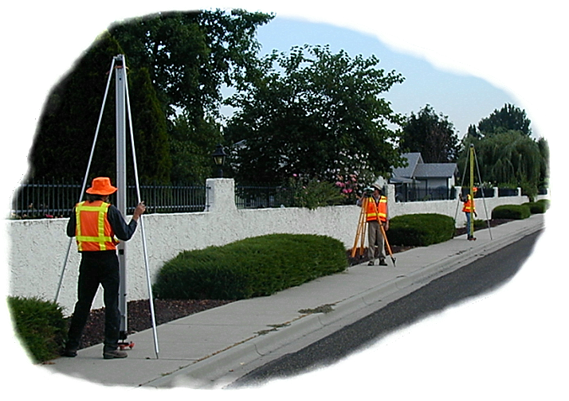Note: the field procedures taught can be applied to all leveling to improve the precision of your leveling.

Days 1 & 2 will concentrate on field operations (i.e. specifications, survey planning, equipment requirements, and field procedures). Field exercises will be conducted outdoors, near the hotel.

Day 3 will concentrate on using NGS software to process and format the data for submission to NGS.

Materials: Course materials, including the presentation, software, equipment references, manuals/specifications, etc. can be downloaded prior to the workshop at: ftp://ftp.ngs.noaa.gov/dist/csmith/ ;
Note: printed material will NOT be provided at the workshop.

Registration: Contact Bill Stone at william.stone@noaa.gov or 505-277-3622 x252 to reserve seats or for more information.

